Q1)Implement an MPI program using N processes to find:
1! + 2! + ..... + N!
Use scan. Also, handle different errors using error handling routines.

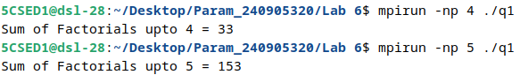

Q2)Implement an MPI program to read a 3 × 3 matrix. Enter an element to be searched in the root process. Find the number of occurrences of this element in the matrix using three processes.

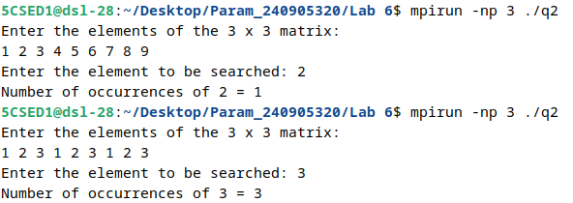

Q3)Implement an MPI program to read a 4 × 4 matrix and display the following output using four processes.
Input: Output:
1 2 3 4 1 2 3 4
1 2 3 1 2 4 6 5
1 1 1 1 3 5 7 6
2 1 2 1 5 6 9 7

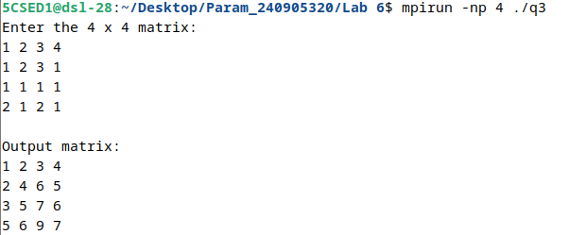

Q4)Implement parallel Odd-Even Transposition Sort.
